- Red raspberry coulis served with a dense slice of chocolate cake
- Rich caramel sauce on a warm apple tart
- Hot fudge sauce on poached pears and vanilla ice cream
- Sabayon with a liqueur soufflé, or
- A strawberry sauce with cream hearts to garnish for a valentine’s dessert.
These are all touches that really make the dessert memorable.
Served on the side in a sauceboat or presented on the plate and enhanced with a piped design, the sauce can add a tremendous amount to the presentation as well as to the flavour of the dessert.

Types of Dessert Sauces
Dessert sauces can be generally categorised as follows, although there are many variations of each, as well as hybrids that combine two or more types:
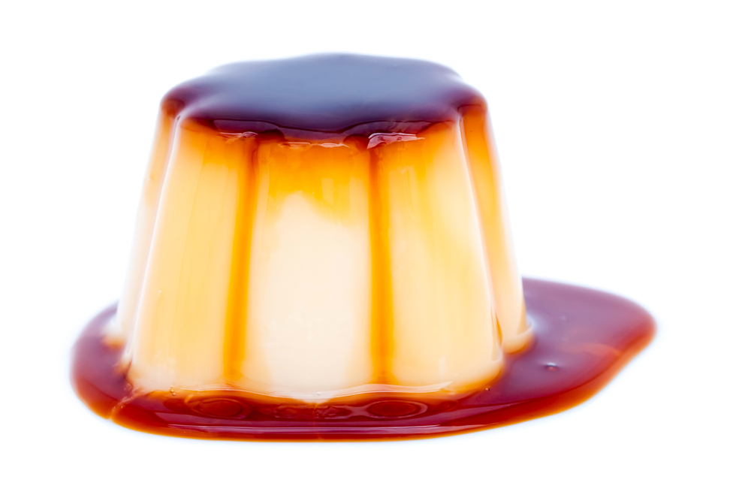
Caramel Sauces
Caramel sauces are prepared by melting and caramelizing sugar to the desired colour, then by adding a liquid (in most cases water) to thin it to a sauce like consistency.
For the most basic caramel sauce nothing else is added.
For a richer caramel sauce, cream and/or butter are incorporated (referred to as a butterscotch sauce).
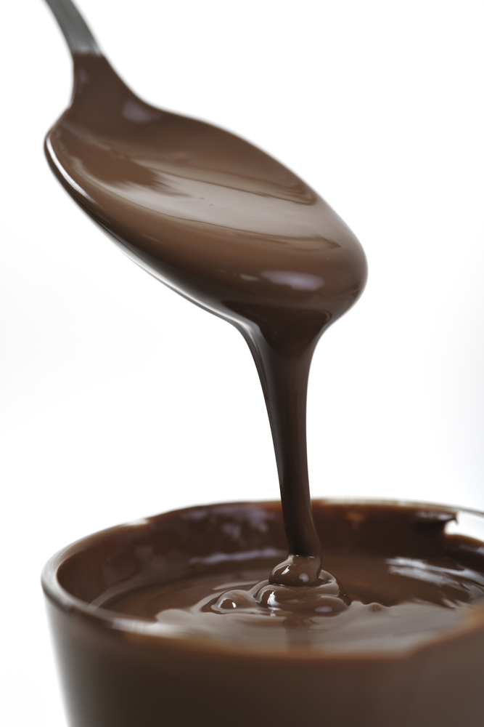
Other flavourings can be added to a basic caramel including spirits such as calvados and rum.
Chocolate Sauces
Chocolate sauces are of course, used extensively.
They may be hot or cold, and either thin for masking a plate or very thick and rich, as a fudge sauce.
A basic chocolate sauce is made from chocolate and/or cocoa powder, sugar and water cooked together.
Richer versions contain the additions of cream and/or butter.
Coulis
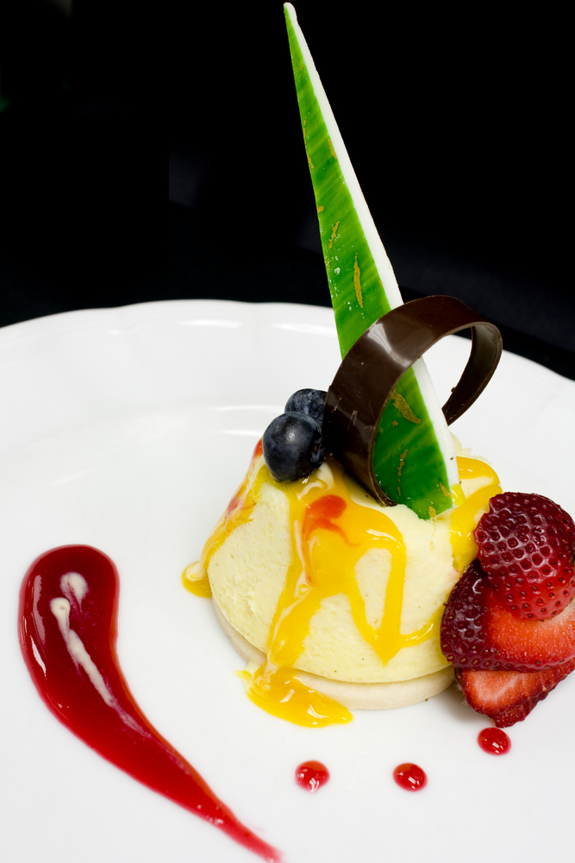
In the pastry kitchen, the term coulis is used for berry juices and fruit purees that are sweetened as needed, usually strained, then served as sauces.
The term coulis has been used for as long as 600 years to refer to strained gravy or broth served with savoury dishes.
It comes from an old French word ‘coleis’, meaning straining, pouring, flowing or sliding.

Traditionally coulis were neither thickened nor bound, however today it is common practice for them to be slightly thickened. A coulis is most commonly made from berries, usually raspberry as they are high in pectin.
Pectin is an enzyme found in some fruits which assists in the thickening or setting of products.
Raspberries are cooked with sugar and water then strained to remove the seeds, and cooled.
Coulis are usually served cold, as a sauce or part of a compote.
A well-made coulis should not separate when poured on a plate, the sauce should be cooked sufficiently to enact the pectin and therefore thicken the sauce.
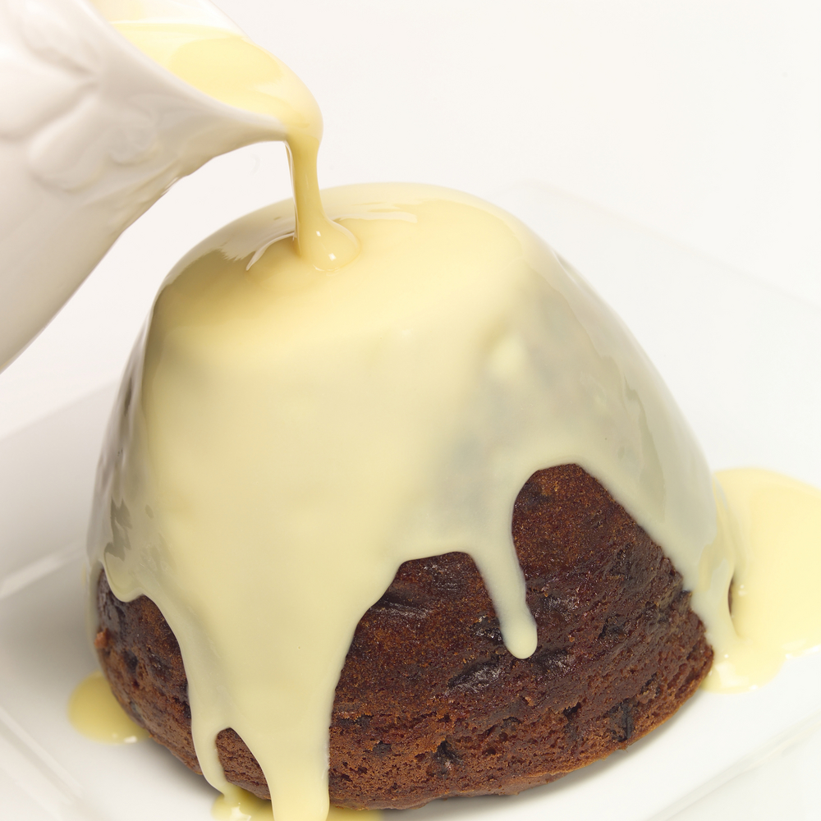
Custard Sauces
The foundational custard sauce is crème Anglaise, also known as vanilla custard sauce.
It is considered the mother sauce of the pastry kitchen.
Not only can many other custard sauces, such as chocolate or coffee flavoured sauce, be prepared from this base, but the ingredients and method of preparation for crème Anglaise are the starting point for many other dessert preparations.
Crème Anglaise is also called English custard or Sauce anglaise.
Custard sauces are made by thickening milk, cream, sugar and eggs using either direct heat or a Bain Marie.
How to make Cream Anglaise
- The milk, cream and vanilla are heated with a little sugar sprinkled on the bottom of the pot to prevent the milk from sticking
- Eggs yolks and sugar are whisked together in a separate bowl
- Pour the boiled milk mixture onto the yolks stirring constantly so the egg yolk does not cook and form lumps
- Return mixture to the pot and cook gently over low heat, stirring constantly
- The custard is cooked when it coats the back of a spoon, which is approximately 82°C.
Over-cooked crème Anglaise is not acceptable. It will appear lumpy, like scrambled egg.
This is due to the egg over coagulating which is the tightening of the proteins that separate the curds and whey. The sauce cannot be used, as it will no longer be smooth and velvety, and the taste will be very strong in egg.
When crème Anglaise is cooked it can be strained and chilled immediately, or strained and kept warm for service:
- Crème Anglaise should be stored covered, in a clean container in the cool room until used within the next 2–3 days.
Ideally this sauce should never be reheated, as the proteins found within the yolks will coagulate very easily.
However, by carefully reheating the Anglaise in a Bain Marie slowly and stirring constantly, this can be avoided.
Fresh Cream or Sour Cream Sauces
Crème fraiche, clotted cream and sour cream are all used as dessert sauces and toppings, sometimes thinned and/or sweetened.
They most frequently accompany fresh fruit but are also served with warm baked fruit desserts, such as an apple tart.
These may be flavoured with vanilla or a spice such as cinnamon.
Fresh cream is used as a sauce both in the form of a heavy cream that is lightly thickened by whipping and whipped cream, or Chantilly cream, which is really more of a topping.
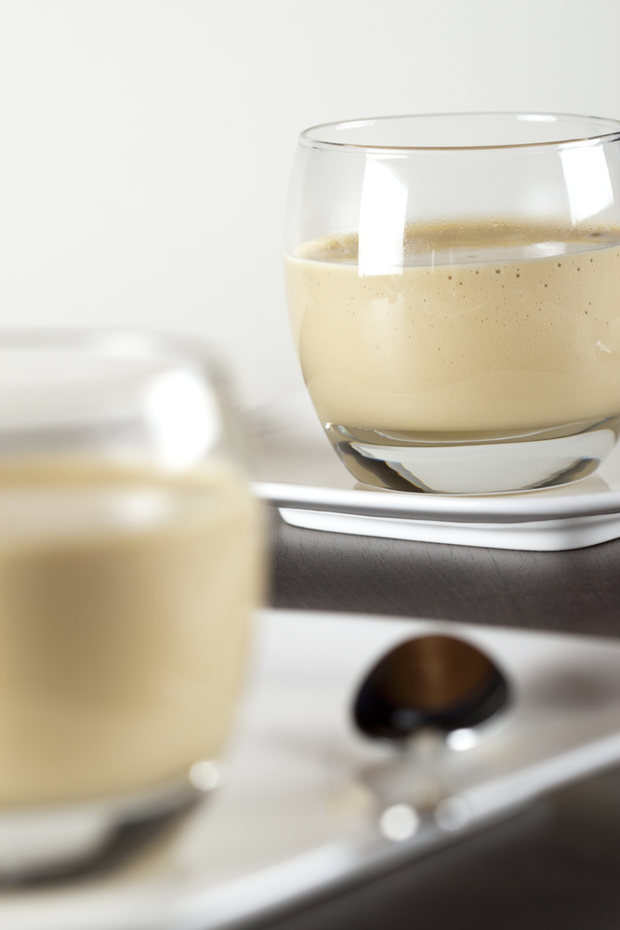
Sabayon Sauces
Sabayon sauces can be hot or cold and are made by thickening wine by whipping it over heat together with egg yolks and sugar.
Sabayon sauces are served with fruit and with soufflés. Sabayon is also served as a dessert by itself.
The Italian version of sabayon, zabaglione, is made with Marsala.
Starch Thickened Sauces
Most fruit sauces are thickened with starch. This can include cornstarch and arrowroot.
They are generally cooked quickly to allow the starch to gelatinize and eliminate the raw starch taste.
Fruit juice sauces thickened with cornflour will be cloudy. Made with arrowroot they will be clearer and softer.
Starches are also used to thicken sauces made of cream or milk and sauces based on spirits or liqueurs.
Sweet sauces will be made in batches.
What is the rate of usage?
This will determine the size of the batch when production is decided.
If the average rate of usage is 50 ml per serving on average and 100 serves will be needed per service and 2 services per day are required.
Activity
How much needs to be made for a batch size to last 2 days.
Remember: Allow 10% extra for variations of serving sizes and spillages.
Sauces need to be made in sizes that can be managed. Some sauces can be made into larger batches and then frozen.
Do not freeze in one large container. Break down into smaller container to more manageable sizes.
If frozen in one large batch it will need to be thawed in one lot, cannot be re-frozen.
Fresh sauces have a life of no more than 2-3 days.

2.3 Store sweet sauces for use in a service period or for use at another occasion
Service Period
Sauce used during service periods need to be treated differently.
When sauces are made in batches they can be divided into smaller containers for service periods.
Hot sauces
Some sauces will need to be heated for service then used. Sauces cannot be reheated a second time.
Food Safety plans should be in place in all foods production premises.
Only heat what is expected to be required for service. More can always be re-heated as required.
Cold sauces
Sauces that are kept chilled are easier to handle. Sauces should never be more than 2-3 days at this temperature:
- At the end of service always decant left over sauce into clean container and re-label and re-seal
- Do not leave spoons in sauces
- NEVER top up sauce with fresh sauce
- NEVER add old sauce to new sauce.
Sauce that has been out of controlled environment for more than the specified period needs to be discarded.
If a sauce has been out on buffet display then it does not get used again. Discard.
WHY? When food is placed outside the kitchen production area it cannot be known what has happened to this product:
- Who has touched it?
- Has it been contaminated?
It cannot be considered safe to be placed back into the food production area.
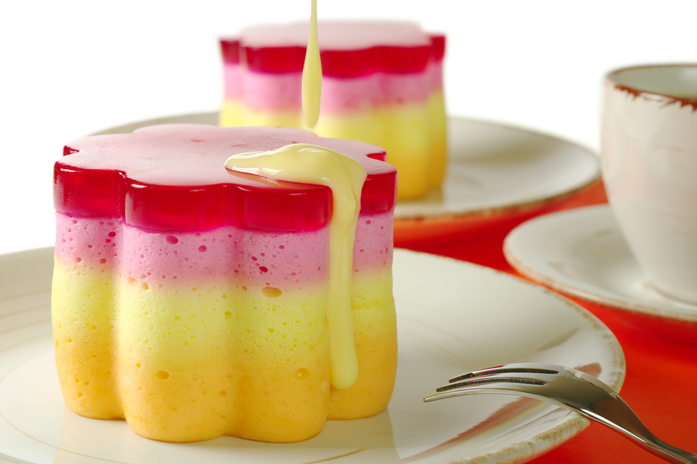
Better safe than sorry

Work Projects
It is a requirement of this Unit you complete Work Projects as advised by your Trainer.
You must submit documentation, suitable evidence or other relevant proof of completion of the project by the agreed date with your Trainer.
Student will need to be able to demonstrate competency by demonstrating ability to produce a wide of desserts.
Working with your trainer you will need to be able to produce a variety of desserts.
Plan the desserts to meet following stages. A report or work plan will need to be prepared before you start.
The report will show the sequence of production and all commodities and equipment that will be required to produce the selected desserts.
Prepare and Store Sweet sauces
Each of the desserts will require a sauce to be prepared and served as part of the dish.
2.1 Select commodities required to make the sauces.
2.2. Prepare the required sauces:
- Sauces should be a variety, Selection of a fruit coulis, cooked sugar based sauce and Anglaise sauce that has been suitable flavoured.
2.3. Store the prepared sauces until required for service:
- Be aware of any Food safety requirements when using high risk ingredient
- Be sure to label and date all sauces produced.

Summary

Prepare and store sweet sauces
Select required commodities
Commodities need to be listed in standard recipe
If made to a standard enterprise recipe then a standard has been met
The selected commodity does not have to be the best quality. It needs to be the required commodity.
Prepare and produce a range of sweet sauces to enterprise requirements and standards
Does the sauce need extra colouring just to look brighter
Enterprise standards and requirements will determine the answer to this question.
Store sweet sauces for use in a service period
Sauces stored for immediate service need to be separated from those for future service
Do not mix old and new sauces.
Store sweet sauces for use at another occasion
Never put old sauces with new sauces in same container
Ensure that the method of storage is not going to impact on the food safety and quality of that products
Sauces that have been exposed to room temperature for prolonged periods are not 'saved' for another time
Use smaller batches or keep sauces at chilled temperature at all times.

Element 3:
Prepare accompaniments, garnishes and decorations

3.1 Plan accompaniments, garnishes and decorations for desserts

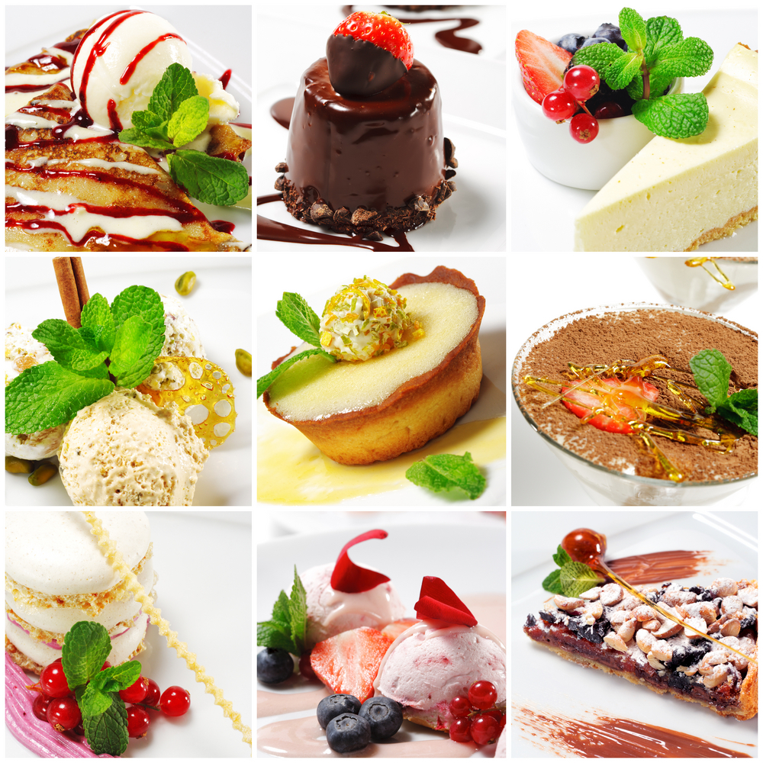
Garnishing
Desserts may include a garnish to decorate and enhance the dish.
The garnish should complement the ingredients.
An example of this is Lemon Tart, garnished with candied lemon zest or Chocolate mousse garnished with chocolate curls.
Different types of Garnish:
- Chocolates  - Tuilles  - Lace Biscuits  - Glass Biscuits  - Brandy Snap  - Florentine  - Choux Pastry  - Puff Pastry  - Short pastry  - Almond Bread/Biscotti | - Praline/Nougat  - Fruits (poached, dried, fresh, baked, caramelized, marinated, candied and stewed)  - Meringue  - Nuts  - Sugar Caramel  - Spring roll wrapper  - Phyllo Pastry  - Pate a brik pastry.
Presentation
It is the presentation of desserts that give the dish the “WOW” factor and will leave a lasting impression with your customers.
There are many techniques that can be used to enhance the presentation of desserts.
One of these is to present the sweet standing up to give it some height on the plate.
This can simply be achieved by making use of plastic dariole moulds or PVC tubes lined with acetate, or in a terrine mould then sliced For example semi-freddo.
Various biscuits (brandy snaps, wafers, or tuilles), sugar bark or pulled sugar, chocolate (white, dark milk or a combination of these) in various shapes can be used.
Fruits (dried, caramelized, compote) can also be included.

3.2 Prepare accompaniments, garnishes and decorations for desserts
Chocolate
Chocolate is very adaptable to be used as garnishes on desserts. When melted it can be:
- Piped Into Motifs And Shapes
- Moulded To Shape
- Spread On Bench And Shaved, Curled
- Spread onto baking paper and cut to shape while cooling.
When cooled the shapes needs to be stored in containers.
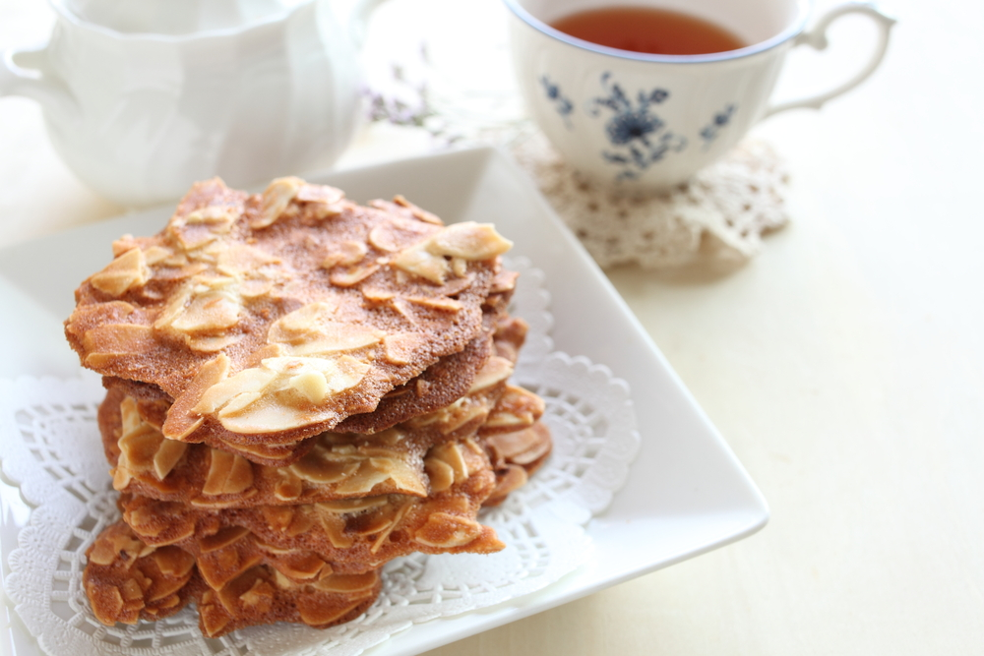
Tuilles
Tuilles are a thin paste of eggwhite, sugar, flour and almond (ground or paste) which is spread into a shape either freehand or using a stencil, then is baked until it is lightly coloured. It is quickly removed from the tray and moulded immediately. The baked tuille will harden within 5 seconds and become brittle.
Lace/Glass Biscuits
High sugar dough that spread thinly when baked. Similar to brandy snap but made with liquid glucose rather than golden syrup.
Sugar and nuts ground together then sprinkled on greased baking tray or silicon mat and baked in oven until sugar melts but does not colour. Hard crack 155°C.
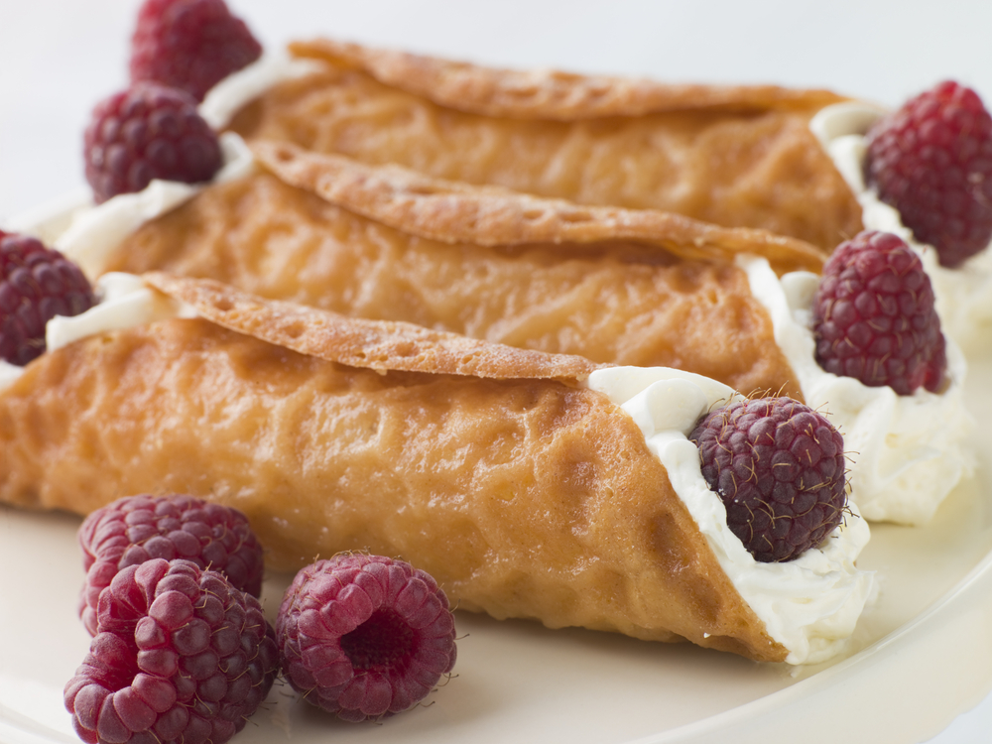
Brandy Snap
A mixture of sugar, butter, flour, golden syrup and butter is baked on well-greased tray or a silicon sheet covered tray. The mixture will spread broadly to form a web like structure:
- Needing to sit on tray for long time to cool before being shaped as it cools
- Needs to stay on mould until cooled. Very fragile.
When cooled can be broken to be used as presentation on desserts.
Florentine
Flaked almond, sugar, honey, fruits
Choux Pastry
Small motifs can be used for garnishes, piped to shape
Puff Pastry
Cut to shapes to be used a décor on desserts

Short pastry
Cut to shapes to be used a décor on desserts
Almond Bread
Mixture of meringue, nuts and flour is baked in forms and when it is cooled the loaf is sliced thinly and baked in moderate one to crisp.
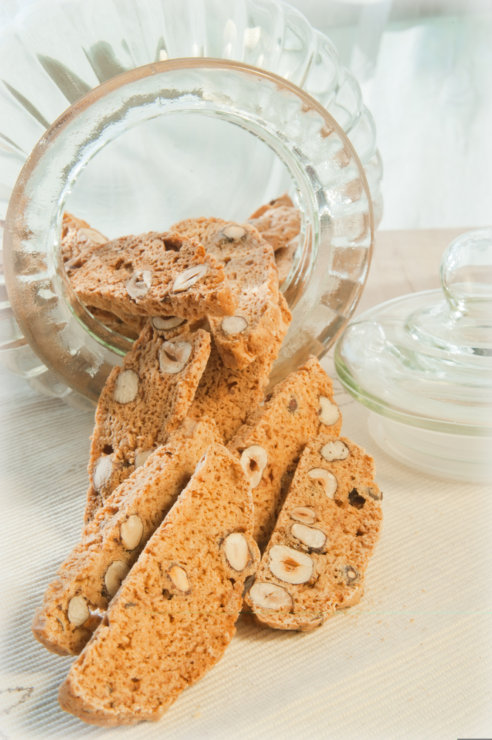
Biscotti
Italian style ‘twice baked’ biscuit that can be used for garnish.
Praline/Nougat
Sugar cooked to caramel colour; light amber, and allowed to cool. Can have nuts added for flavour and character.
Nougat is caramelised sugar and hazelnuts that when cool have been ground together to form a paste. Chocolate can be added to give slightly different flavour.
Fruits
(Poached, dried, fresh, baked, caramelized, marinated, candied and stewed).
Meringue
Piped to shape and baked. Used as décor for desserts
Nuts
Roasted for flavour improvement can be flaked, nibbed, slivered ground.
Sugar Caramel
Caramelised sugar is spread over baking parchment and then broken into pieces when cool.
Spring roll wrapper
Fine pastry that is normally used for savoury wrap can be sprinkled with sugar and baked to caramelise the sugar. Can be cut to shape or broken over top.
Phyllo/Pate a’brik pastry
Fine pastry that is normally used for savoury wrap can be sprinkled with sugar and baked to caramelise the sugar. Can be cut to shape or broken over top.
Many decors can be made for use as garnishes.
Rules:
- They must be edible
- Fine in texture
- Small in size
- Compliment the dessert.
Do not use same décor on all desserts.
Work Projects
It is a requirement of this Unit you complete Work Projects as advised by your Trainer.
You must submit documentation, suitable evidence or other relevant proof of completion of the project by the agreed date to with your Trainer.
Student will need to be able to demonstrate competency by demonstrating ability to produce a wide of desserts.
Working with your trainer you will need to be able to produce a variety of desserts.
Plan the desserts to meet following stages. A report or work plan will need to be prepared before you start.
The report will show the sequence of production and all commodities and equipment that will be required to produce the selected desserts.
Prepare accompaniments
3.1 Plan accompaniments and garnishes:
- Make a list of all 'extras' that will be used to decorate the desserts
- What ingredients that might be required to produce decors.
3.2. Prepare and store accompaniments until required.

Summary

Prepare accompaniments, garnishes and decorations
Plan accompaniments
Accompaniments will have a short life and will be fragile if handled badly. So planning what type to make and how many to make will be impacted
When planning excess need to be produced to allow for breakages and quality deterioration if handled badly.
Prepare accompaniments
Following pre-planned recipes prepare what is required.

Element 4:
Store hot, cold and frozen desserts

4.1 Store desserts at appropriate temperature and conditions to maintain quality, freshness and customer appeal

Store Cold Desserts
Cold desserts will need to be stored in controlled environment.
Dairy based desserts
Product with ingredients such as milk, eggs and cream will need to be stored in a controlled environment:
- 4°C or less for fresh
- -18°C for frozen.
Fresh desserts that are made with fresh cream held in suspension with setting agents such as gelatine, agar and alginate thickeners will have a shelf life of approximately 3 days if kept protected from the environment.
This product needs to be covered when placed into the coolroom. The surface will develop a skin if left uncovered.
Dairy based desserts that are frozen will keep for several months in controlled environment.
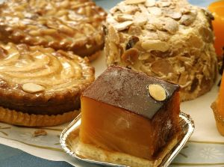
Example:
- Ice creams
- Parfaits
- Mousses.
Fruit and pastry based desserts
- Apple pies
- Apple strudels
- Compote of fresh fruit.
These types of desserts do not contain dairy products but still need to be kept chilled for food safety reasons.
The pastry will start to soften when kept in cool room. The drier the environment the better the pastry will keep.
These can be wrapped securely which will minimise possibility of them being damaged.

Baked Pastry
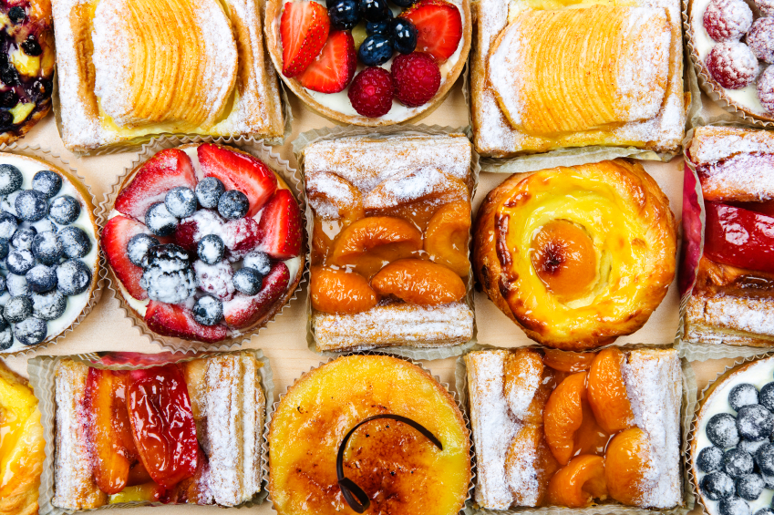
Pastry that has been baked ready for filling can be stored at room temperature until required if protected from adverse conditions and outside contamination:
- Shortbread disc and shells
- Pastry discs.
These do not need to be chilled. They just need to be placed into food grade secure containers.
Store non dairy dessert items
Some items do not need to be chilled when being stored.
Pastry products and garnishes only need to be kept in secure environment:
- Wrapped in food safe containers and labelled.
Sugar based garnishes need to be stored:
- In food safe container
- Well wrapped
- To stop moisture from the air causing product to soften.
Glacé fruits can be stored at room temperature if kept in syrup with which they were purchased. They will start to dehydrate and loss sheen.

4.2 Pack down desserts to ensure taste, appearance and textures are maintained
Packing down
‘Packing down’ is a term used to describe the action of securing and storing the product securely until required.
Cooks ‘pack done’ a kitchen at the end of service.
Pastrycooks pack desserts away for safe storage until required for sale or service period.
All product needs to be packaged so that the integrity of the product is not compromised during storage.
Ice cream is placed into freezer compatible food safe containers before being wrapped securely, labelled and stored in the freezer until it is required.
Fresh desserts that have not sold would be stored in container that will allow them to be covered without destroying any garnish that might be placed on top.
Wrapping or covering is the most dangerous part of keeping integrity in place. Any container that is the wrong size will cause damage to finished product.

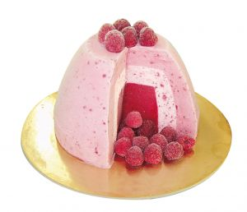
Stages of production
Producing desserts skill is time management and planning. Very rarely are all desserts made the day they are sold. Timelines can be as much as 3 days. Frozen desserts may have been produced 2 – 3 weeks before.
Maturing of flavours
Some products need to sit for a period of time so flavours can mature.
English style puddings produced for the Christmas period might be made 3 months before they are needed.
Sauces
Sauces need to be kept chilled until needed. If any sauce has been reheated for service then it must not be re-chilled and stored.
It is good management not to reheat more than what will be required.
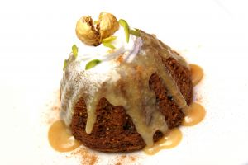
Work Projects
It is a requirement of this Unit you complete Work Projects as advised by your Trainer.
You must submit documentation, suitable evidence or other relevant proof of completion of the project by the agreed date with your Trainer.
Student will need to be able to demonstrate competency by demonstrating ability to produce a wide of desserts.
Working with your trainer you will need to be able to produce a variety of desserts.
Plan the desserts to meet following stages. A report or work plan will need to be prepared before you start.
The report will show the sequence of production and all commodities and equipment that will be required to produce the selected desserts.
Store hot and cold desserts
As part of the report the student will have to identify the following requirements to the satisfaction of the trainer.
4.1 Store desserts at the required temperature to ensure quality is not diminished by the storage:
- What temperature is each dessert, from the selection that has been chosen, needs to be maintained in order for the dessert to be of saleable quality at a later stage?
4.2. Pack down desserts:
- How does the dessert need to be packed in order for the shape, taste and eating quality to be preserved?
Students need to be able to supply the above information to be deemed competent in the learning outcomes listed at the beginning of this book.

Summary

Store hot, cold and frozen desserts
Store desserts at appropriate temperatures to ensure quality is maintained
Pack down desserts to ensure quality is ensured for a later date.

Appendices: Recipes

Summer pudding
Ingredients | Quantity
Berries, frozen  Sugar  Water  Bread | 300 gm  40 gm  40 ml  3- 4 Slices
Method:
- Heat sugar and water; add 80 gm of the berries
- Stir and crush the berries with a spoon or whisk to release the colour
- Add remaining berries, warm through
- Line the plastic dariole moulds with bread cut to 6.5 ml thick, and cut to shape
- Place the berries in to slightly over full
- Cover with cling film and place on a tray with a weight on top to press. Chill before serving
- This dessert is best made the day before use to allow the colour to penetrate through the bread.

White Wine Jelly
Ingredients | Quantity
White wine  Lemon, juiced  Sugar  Gelatine leaves  Small quantity of fruit to be suspended in the jelly | 250 ml  ½  60 gm  3
Method:
- Heat the wine, lemon juice and sugar
- Soak the gelatine in cold water until softened
- Squeeze out excess water from the gelatine, add to the hot wine
- Gently stir in the gelatine until dissolved, avoiding the formation of air bubbles
- Pass through a fine strainer, allow to cool
- Layer the cool jelly with slices of fruit, allowing each layer to set before beginning the next
- Chill and decorate.

Pithivier
Ingredients | Quantity
Puff Pastry  Frangipane  Rum  Egg wash  Icing Sugar | 2 sheets  25 gm
Method:
- Roll pastry to a thickness of 3 mm
- Cut two circles, approximately 18cm in diameter. Place one on a baking tray
- Mix a splash of rum into the frangipane. Spread the frangipane onto the pastry which is on the tray, leaving a 1 cm border around the edge free. Brush the edge border with egg wash and scallop this edge
- Place the larger circle of pastry on top and seal well. Brush with egg wash. With the point of a sharp knife make curved cuts approximately 1mm deep radiating from the centre to the edge. Allow to rest in a cool place for approximately 30 minutes
- Bake at 215°C for approximately 20 – 30 minutes. Once removed from the oven then dredge with icing sugar and return to the oven to glaze or glaze very carefully under the salamander.

Frangipane
(Per 2 students)
Ingredients | Quantity
Unsalted Butter  Sugar, castor  Egg  Flour  Almonds, ground | 80 gm  80 gm  1  20gm  80 gm
Method:
- Beat thoroughly together the butter and sugar until light and creamy
- Beat the egg and gradually add to the mixture beating in well
- Sieve the flour. Add to the mixture with almond meal, mix together lightly.

Strawberry Sable
Ingredients | Quantity
Unsalted Butter  Castor Sugar  Bakers Flour  Cornflour  Baking Powder  Salt  Egg lightly beaten  Few drops of vanilla | 125 gm  50 gm  100 gm  50 gm  1/4 tsp  1/4 tsp  1/2
Method:
- Cream butter and sugar
- Add egg slowly with vanilla
- Add dry ingredients
- Do not overwork
- Rest
- Roll out approximately 3mm thick
- Cut with round cutters
- Place on baking sheet
- Rest
- Bake at 160ºC without colour for approximately 10 – 12 minutes
- Make sure Sables are crisp.

Assembling for Strawberry Sable:
Ingredients | Quantity
Strawberries  Cream  Icing Sugar  Few drops Vanilla Essence | 5  100ml  1 tsp
Method:
- Take 3 sable
- Whip cream with vanilla and sugar to firm peaks
- Wash strawberries dry and cut in half
- Place cream on 2 disks and decorate with strawberry halves
- Place on top of each other
- Place last disk on top which is dusted with icing sugar
- Place on to a plate decorate with Anglaise and raspberry coulis
- Serve.

Sweet Paste
Ingredients | Quantity
Unsalted Butter  Sugar, castor  Egg  Flour  Cornflour | 125 gm  125 gm  1  200 gm  50 gm
Method:
- Cream butter and sugar
- Gradually add eggs one at a time beating thoroughly
- Gently fold in the flour until well combined. Do not over mix
- Wrap the pastry in glad wrap and refrigerate for 1 hour
- Roll the pastry to desired thickness, usually 2 – 3 mm to line a flan tin. Ensure the pastry is carefully pushed into the corners of the tin without tearing the pastry
- Make a paper cartouche and cover the pastry with it, then fill with baking pulses or rice
- Cook pastry in the oven at 180°C for 8 minutes. Check the edges of the pastry, when they are set and pale gold in colour, remove the paper and pulses and return the pastry to the oven for another 3 – 5 minutes until completely cooked, and a light golden brown colour
- Remove from the oven and cool.

Roast Pear
Ingredients | Quantity
Butter  Pear, peeled and cored  Sugar  Water | 20 gm  ½  30 gm  30 ml
Method:
- Preheat oven to 180 – 200ºC
- Lightly butter an oven proof dish, place prepared pear in and dot with remaining butter
- Sprinkle with sugar; add water to the bottom of the dish. ( this will prevent the butter and sugar from burning while the pear is cooking)
- Place dish in the oven and cook for approximately 20 minutes. Turning the pear over half way through the cooking
- The pear is cooked when a small skewer easily inserts into the pear.

Chocolate Sauce
Ingredients | Quantity
Dark Chocolate, chopped  Milk  Cream  Sugar | 175 gm  75 ml  125 ml  30 gm
Method:
- Melt chocolate pieces with milk and sugar over a double boiler
- Add cream and mix in thoroughly
- Strain through a fine strainer.
Note:
This sauce can be served warm or cold. It may need to be thinned with more liquid if it is served cold.

Crème Pâtissière
Ingredients | Quantity
Stage 1:  Flour  Custard Powder  Sugar  Egg yolks  Milk | 20 gm  15 gm  20 gm  2  40 ml
Stage 2:  Milk  Sugar  Vanilla bean | 300  35 gm  1/2
Method:
- Make a paste from stage 1, by first combining sugar and egg yolks, then add milk, flour and custard powder and mix to a smooth paste
- For stage 2 pour the milk into a saucepan and add a split vanilla bean
- Next add the sugar by dropping it evenly over the whole surface, (do not stir as the sugar acts as an insulator and prevents the milk from sticking to the pan)
- Place on heat and bring nearly to the boil
- Now slowly pour the hot milk in to the paste from stage 1 while stirring to avoid lumps
- Place back in the pot, bring to boil and simmer for approx 2 minutes while continuously stirring
- Transfer to a container and cover with a greased cartouche to prevent a skin forming.

Orange Sabayon Sauce
Ingredients | Quantity
Egg Yolks  Sugar  Grand Marnier  Orange Juice  Lemon Juice | 2  25 gm  20 ml  25 ml  8 ml
Method:
- Bring a pot of water to the boil, then turn off the heat
- Combine all ingredients in a stainless bowl
- Place the bowl of egg mixture over the hot water
- Whisk vigorously to aerate as demonstrated and continue the whisking process until you can hold a figure 8 in your sabayon
- Be careful not to overcook, you will lose aeration and the sauce will become heavy.
Note:
This sauce can used nappe over sliced fruits and gratinated under salamander until light golden brown.

Butterscotch Sauce
Ingredients | Quantity
Butter  Brown Sugar  Cream  vanilla essence | 20 gm  100 gm  150 ml  Trace
Method:
- Gently melt butter
- Add brown sugar and boil for approximately 2 to 3 minutes
- Add cream & vanilla essence and cook till correct consistency
- Remove from heat and allow to cool.
Note:
Butterscotch sauce is usually served with puddings.

Sauce Anglaise
Ingredients | Quantity
Milk  Vanilla bean  Sugar  Egg Yolks | 500 ml  ½  65 gm  5
Method:
- Bring milk, vanilla and 20 gm of sugar to the boil in a pan
- Mix eggs and remaining sugar together in a bowl
- Add hot milk and vanilla to egg and sugar mixture, whisking constantly
- Return mix to the pan and heat gently, stirring with a wooden spoon until it thickens and coats the back of a spoon (82ºC)
- Pass through a chinois immediately and cool.
Note:
Do not allow to boil as the sauce will curdle.
Sauce Anglaise is used as a base for ice cream, some mousses, Bavarian cream (Bavarois) or used as a sauce which can be flavoured.

Raspberry Coulis
Ingredients | Quantity
Raspberries  Water  Sugar | 200 gm  25 ml  25 ml
Method:
- Place water and sugar in a pan and bring to the boil
- Add raspberries bring to boil and simmer for 3 minutes and puree.

Individual Lemon Meringue Pie
Ingredients | Quantity
Sweet Pastry Bases (10cm)  Eggs  Egg yolks  Lemon juice  Sugar  Butter  Gelatine  Lemon, zested | 2  3  3  60 ml  60 gm  65 gm  3/4 sheet  1/2
Method:
- Blind bake a 10 cm tart base using sweet pastry. Let cool
- Soak gelatine leaf in cold water to soften. Lightly beat eggs and yolks
- Bring lemon zest, juice and sugar to the boil
- Add eggs and cook out until thick
- Add softened gelatine and butter off the heat, stirring to combine
- Pour mix into tart base and refrigerate until set
- Next pipe Italian meringue on top and glaze.

Italian Meringue
Ingredients | Quantity
Egg whites (5)  Castor Sugar  Water | 140 ml  280 gm  100 ml
Method:
- Bring sugar & water to the boil. Wash sides of pot with a wet pastry brush to prevent crystallization
- Boil steadily until the syrup reaches 118°C on sugar thermometer
- Whisk whites to soft peaks
- Slowly pour syrup into whites in a steady stream continuing to whisk until cold.

Meringues
French
Ingredients | Quantity
Egg whites (6)  Castor Sugar  Castor Sugar | 175 ml  240 gm  100 gm
Method:
- Whisk egg whites to soft peak
- Rain in 2/3 of the sugar whilst beating continuously
- Mix for another 30 seconds
- Remove from the machine and fold the remaining sugar through the meringue
- Do not over mix, you will lose volume
- Pipe onto prepared tray into desired shape or mix into cream base for dessert
- Bake at approx 120 – 130°C for approx 30 mins then prop the door ajar to allow the steam to escape. Bake until dry, time will vary according to the size of the product.
Note:
This is the basic meringue. It should be used immediately, the mixture is not stable.
Some baked meringue formulas will have cornflour in the second lot of sugar; this will add some stability as the product bakes.

Floating Islands
‘Floating Islands’ is a dessert made of French meringue poached in hot milk and then the milk made into an anglaise sauce.
Ingredients | Quantity
Milk  Egg Yolk  Sugar  French Meringue | 250ml  1  50 gm  1 portion
Method:
- Whisk the egg yolk and sugar together then set aside
- Place the milk into a shallow pan and bring to the boil, turn down to poaching temperature
- Quenelle the meringue with a dessertspoon and 3 pieces per portion and poach in the hot milk
- When the meringue is cooked remove and set aside on absorbent paper
- Use the milk to produce and anglaise sauce with the reserved egg/sugar mix.
To Serve
Place the sauce onto a warm clean plate then position the warm meringue islands on top of the sauce.

Meringue Roulade
Chocolate |  | Vanilla
Ingredients | Quantity | Ingredients | Quantity
Egg White  Castor sugar  Corn flour  Cocoa powder  Castor sugar | 150 ml  100 gm  15 gm  10 gm  50 gm | Egg White  Caster sugar  Vanilla Essence  Castor Sugar  Corn flour | 150 ml  100 ml  5 ml  50 gm  15 gm
Filling for either
Ingredients | Quantity
Cream, whipped  Sugar | 300 gm  To taste
Method:
- Prepare tray by lining baking tray 45 x 30 cm with silicon paper
- Make sure paper is up the sides
- Measure all ingredients
- Place egg whites into clean bowl, place onto ‘kitchen aid’ and begin whipping on highest speed
- Whisk whites to soft peak, then gently pour in 1st measure of sugar and continue beating to firm peaks, 30 seconds
- Sift the dry ingredients twice, and fold gently into meringue maintaining as much volume as possible
- Spread 1 cm thickness onto a silicon lined baking sheet
- Bake at 200°C for approx. 10 minutes
- Remove from the oven and leave on the baking tray to steam (this loosens the paper from the roulade)
- Invert onto a sheet of paper sprinkled with castor sugar. Allow to cool
- Gently remove silicon paper from bottom of meringue
- Be careful not to remove too quickly or else you will tear the sheet of meringue
- Spread with whipped cream, fill with fruit and roll up with cling film or silicon paper.

Chocolate Pavlova Roulade
Ingredients | Quantity
Egg White  Lemon Juice  Castor Sugar  Corn flour  Cocoa powder  Caster sugar  A1 Sugar, sprinkle on silicon paper for rolling | 200 ml  5 ml  120 gm  20 gm  20 gm  80 gm  100 gm
Filling for Roulade
Ingredients | Quantity
Cream, whipped  Sugar  Fruit of choice, diced | 300 gm  To taste  100 gm
Method:
- Prepare tray by lining baking tray 45 x 30 cm with silicon paper
- Make sure paper is up the sides
- Measure all ingredients
- Place egg whites into clean bowl, place onto ‘kitchen aid’ and begin whipping on highest speed
- Whisk whites to soft peak, then gently pour in 1st measure of sugar and continue beating to firm peaks, 30 seconds
- Sift the dry ingredients twice, and fold gently into meringue maintaining as much volume as possible
- Spread even thickness onto a silicon lined baking sheet
- Bake at 200°C for approx. 10 minutes
- Remove from the oven and leave on the baking tray to steam (this loosens the paper from the roulade)
- Invert onto a sheet of paper sprinkled with A1 sugar. Allow to cool
- Gently remove silicon paper from bottom of meringue
- Be careful not to remove too quickly or else you will tear the sheet of meringue
- Spread with whipped cream, fill with fruit and roll up with cling film or silicon paper.

Joconde Sponge
Ingredients | Quantity
Almond meal  Icing Sugar  Eggs  Egg Whites  Sugar  Plain Flour, sifted  Melted Butter | 75 gm  75 gm  2  3  15 gm  25 gm  15 gm
Method:
- Heat oven to 220ºC. Line a baking sheet with silicon paper
- Whisk together the almond meal, icing sugar and eggs to ribbon stage
- Whisk whites to soft peaks and beat in the sugar whisk until medium peak
- Fold the meringue through the almond mixture
- Then gently fold through the flour and melted butter
- Do not over mix
- Spread mixture at 2 – 3 mm thickness quickly and evenly onto the tray and bake in oven for 6 – 7 minutes (Should be a light golden brown colour on top. Deep golden brown will result in a crisp sponge that will crack and not bend).

Crepes
Ingredients | Quantity
Flour  Castor Sugar  Salt  Eggs  Milk | 125 gm  15 gm  2  250 ml
Method:
- Sift dry ingredients into a bowl
- Mix together wet ingredients
- After making a well in the dry ingredients, pour wet ingredients into the well and gradually incorporate ensuring a smooth batter
- Allow to rest for 30 minutes
- When rested process as for crepes.

Charlotte Royale
Ingredients | Quantity
Swiss Roll
Raspberry and Vanilla Bavarois Recipe
Method:
- Slice Swiss roll approximately 5 mm thick
- Line mould
- Place Bavarois mixtures into mould
- Cover with remainder of Swiss roll
- Refrigerate
- Turn out and decorate.

Fruit Flambé
Ingredients | Quantity
Butter  Mixed Fruit  Sugar  Brandy or rum  Orange Juice  Lemon Juice | 10 gm  100 gm  25 gm  25 ml  30 ml  30 ml
Method:
- Place sugar in a heavy based pan and heat until a dry caramel is formed
- Add orange and lemon juice to the pan with 40 ml of water, to avoid the caramel from burning
- Continue to cook for 1 minute
- Cut fruit into an appropriate size to fit the crepe. Add the hard fruit to the pan
- Cook until tender
- Add soft fruit
- Remove pan from heat, add alcohol and ignite
- Burn off the alcohol and cook until fruit is cooked
- Add butter to the sauce and emulsify
- Serve inside a warm crepe and garnish.

Macerated Strawberries
Ingredients | Quantity
Strawberries  Sugar  Curacao  Joconde Sponge disc (See previous recipe)  Sabayon (See next recipe) | 5  10 gm  5 ml  10 cm
Method:
- Wash and hull strawberries
- Macerate with sugar and curacao
- Rest for 15 minutes
- Slice strawberries and fan over sponge
- Nappe with sabayon
- Gratinate under salamander
- Serve.

Orange Sauce
Ingredients | Quantity
Egg Yolks  Sugar  Curacao  Orange Juice  Lemon Juice | 2  25 gm  20 ml  25 ml  8 ml
Method:
- Combine all ingredients in a stainless bowl
- Whisk over a bain-marie, until ribbon consistency is achieved.

Vanilla and Raspberry Bavarois
Vanilla Bavarois
Ingredients | Quantity
Milk  Vanilla Bean (split)  Egg yolks  Castor Sugar  Gelatine  Cream (soft whipped) | 300 ml  Half  3  90 gm  4 leaves  300 ml
Raspberry Bavarois
Add 40ml Raspberry Coulis
Method:
- Soften gelatine leaves in cold water
- Heat milk, vanilla bean and half the sugar until almost boiling
- Blend egg yolks and remaining sugar thoroughly in a bowl
- Pour milk onto egg yolk mixture in the bowl and blend well
- Return the mix to the saucepan and heat gently, stirring continuously
- The mixture is cooked when it coats the back of a spoon. Pass through a chinois into a clean bowl
- Squeeze out excess water from the gelatine leaves and add to the custard, stir until melted
- Strain and divide in half
- Add coulis .to one half and cool
- When mixture is thickening and just starting to set, fold through half the soft whipped cream
- Repeat with vanilla mix.

Japonaise
Ingredients | Quantity
Egg Whites  Castor Sugar  Toasted, ground almonds or hazelnuts  Cornflour  Icing sugar  Vanilla Essence | 3  135 gm  60 gm  15 gm  30 gm  Few drops
Method:
- Whisk egg whites until they form a soft peak
- Slowly rain in sugar and continue beating until meringue is stiff and glossy
- Sift together nuts, cornflour and icing sugar
- Fold dry ingredients into meringue with vanilla essence
- Mark circles on silicon paper and pipe meringue from the centre outwards
- Bake in oven at 150°C for approx 15 – 20 minutes until light golden brown and crisp. Should lift off they tray in one whole piece when ready.

Note: Japonaise is used to make gateaux and smaller cakes for dessert.
Fill with mocha butter cream, flavoured whipped cream or mousse .

Swiss Roll
Ingredients | Quantity
Egg yolks  Sugar  Pinch Salt  Egg Whites  Flour  Cornflour | 4  50 gm  3  40 gm  20 gm
Method:
- Whisk egg whites, slowly add sugar and continue beating to firm peaks
- Combine Egg yolks with salt and mix well do not over beat
- Fold into egg whites
- Fold in sifted flour do not over work
- Line a baking sheet with silicon paper and spray with oil spray
- Spread mix over tray approximately 5mm thick
- Bake at 180 °C for approximately 10 minutes
- Allow to cool
- Turn out onto greaseproof paper which is sprinkled with A1 sugar
- Spread with jam roll up
- Refrigerate.

Tira Mi Su
Ingredients | Quantity
Egg yolks  Castor sugar  Mascarpone  Cream  Egg white  Instant coffee  Boiling water  Kahlua  Joconde sponge  Grated chocolate or cocoa powder | 3  60 gm  200 gm  50 ml  1  1 tsp  40 ml  50 ml  9 discs
Method:
- Make a sabayon with the egg yolks and sugar till ribbon stage. Allow to cool
- Blend together the mascarpone and cream and whisk till just firm and smooth
- Whip egg white to medium peak and fold into the sabayon. Fold through the mascarpone mixture
- Dissolve coffee in the boiling water
- Mix together the Kahlua and coffee
- Brush (or dip) the Joconde sponge discs with the coffee mix
- Place the mascarpone cream mixture in a piping bag
- Assembly: when serving in a glass, start by piping a 1cm layer of the cream in the bottom and top with a disc of Joconde. Continue to alternate layers finishing with the cream. Smooth off and dust with cocoa/chocolate to serve
- For free standing individual portions, start with a disc of Joconde on the bottom as this form a stable base to support the cream. Pipe a 1 cm layer of the cream onto this. Continue to alternate layers finishing with the cream. Smooth off and dust with cocoa/chocolate to serve.

Hot Soufflé Base
Ingredients | Quantity
Stage 1:  Flour  Custard Powder  Sugar  Egg yolk  Milk | 15 gm  15 gm  15 gm  1  100 ml
Stage 2:  Milk  Sugar | 150 ml  20 gm
Method:
- Combine all the ingredients from stage 1
- For stage 2 pour the milk into a saucepan
- Next add the sugar by dropping it evenly over the whole surface. Place on heat and bring to boil
- Slowly pour the hot milk in to the paste from stage 1 while vigorously stirring to avoid lumps
- Place in pot, bring to boil and simmer for approx 2 minutes while continuously stirring
- Transfer to a container and cover with a greased cartouche to prevent a skin forming.
To flavour and finish as a soufflé:
This base is suited to any number of different flavoured soufflés. The use of differing flavouring agents and how they are used will be determined by the nature of the product.
Example:
Production of a berry coulis, taking into consideration the quantity of sugar used.
Reduction of citrus juices and zest with some sugar.
Melted chocolate being incorporated into soufflé base immediately after it has been cooked (while it is still hot). OR cocoa powder being added to dry ingredients when making the base.
Variation in the quantity of eggwhite foam to be used for differing texture in soufflé bases.

Raspberry Soufflé
Ingredients | Quantity
Base  Coulis (6:5 - fruit to sugar cooked to softball)  Eggwhites  Sugar | 100 gm  60 gm  2  20 gm
Method:
- Blend warm base with coulis
- Whip whites to foam, rain in castor sugar and whip to peaks
- Use ¾ of this foam with the quantity of base to make 2 soufflés
- Carefully fold foam into base in three stages, ensuring they are well blended but not over worked
- Cook in a conventional oven at 220º C for 12 minutes or convection at 210º C for 10 minutes.

Orange Grand Marnier Soufflé
Ingredients | Quantity
Orange juice (2 oranges)  Orange zest  Sugar  Grand Marnier  Base  Eggwhites  Sugar | 160 ml  ½  40 gm  20 ml  100 gm  2  20 gm
Method:
- Place orange juice, zest and sugar and reduce by ½
- Blend orange reduction with warm base and then add Grand Marnier
- Whip whites to foam, rain in castor sugar and whip to peaks
- Use ¾ of this foam with the quantity of base to make 2 soufflés
- Carefully fold foam into base in three stages, ensuring they are well blended but not over worked
- Cook in a conventional oven at 220º C for 12 minutes or convection at 210º C for 10 minutes.

Chocolate Soufflé
Ingredients | Quantity
Base  Melted dark coverture OR 50 g melted dark compound chocolate  Eggwhites  Sugar | 100 gm  40 gm  2  20 gm
Method:
- Blend base with melted chocolate while base is still warm
- Whip whites to foam, rain in castor sugar and whip to peaks
- Gently mix ¼ of the foam into base to soften it
- Carefully fold remaining foam into base in three stages, ensuring they are well blended but not over worked. This should yield 2 soufflés
- Cook in a conventional oven at 220º C for 12 minutes or convection at 210º C for 10 minutes.

Hazelnut Soufflés
Ingredients | Quantity
Base  Hazelnut Paste  Frangelico  Eggwhites  Sugar | 100 gm  50 gm  10 ml  2  20 gm
Method:
- Blend base with hazelnut paste while the base is still warm, and then stir in frangelico
- Whip whites to foam, rain in castor sugar and whip to peaks
- Use ¾ of this foam with the quantity of base to make 2 soufflés
- Carefully fold foam into base in three stages, ensuring they are well blended but not over worked
- Cook in a conventional oven at 220ºC for 12 minutes or convection at 210ºC for 10 minutes.

Chocolate Mousse
Ingredients | Quantity
Compound Chocolate  Rum  Cream  Egg Yolk  Cream  Egg White  Castor Sugar | 100 gm  10 ml  25 ml  1  125 ml  1  10 gm
Method:
- Melt chocolate with 25 ml of cream and rum over a double boiler
- Add egg yolk, let cool slightly
- Semi-whip 125 ml of cream
- Whisk egg whites and sugar until soft peak
- Fold cream into the cooled chocolate mixture
- Lastly fold in the egg whites
- Place in fridge to firm.

Panna Cotta
Ingredients | Quantity
Milk  Cream  Star Anise, dry roasted  Vanilla Bean, split  Gelatine, softened in cold water  Sugar | 200 ml  200 ml  1  1/2  2 leaves  50 gm
Method:
- Combine milk, cream, star anise, vanilla bean and sugar in a saucepan and slowly bring to the boil. Reduce the heat and simmer for 1 minute
- Strain through a fine mesh strainer or muslin cloth
- Take off the heat and stir in the softened gelatine leaves. Cool over ice until it begins to thicken
- Pour into dariole moulds and leave to set for at least 4 hours, until firm.
Note: Panna Cotta should set with a slight wobble.

Fruit Compote
Ingredients | Quantity
Sugar  White wine  Water  Cinnamon stick  Orange zest peeled and juice  Lemon zest peeled and juice  Pear  Apple  Strawberries | 50 gm  70ml  70 ml  1/2  1/2  1/2  1/2  1/2  3
Method:
- Prepare syrup by bringing to the boil sugar, white wine, water, cinnamon stick, orange and lemon zest and juice
- Simmer for 5 minutes
- Add pear and apple pieces
- Cook until tender
- Turn off
- Add quartered strawberries
- Cool
- Serve.

Crème Brule
Ingredients | Quantity
Cream  Vanilla Bean  Egg Yolks  Castor Sugar  Extra Castor Sugar | 300 ml  1/2  4  30 gm
Method:
- Place cream and vanilla bean into a pot and bring slowly to scalding point
- Combine egg yolk and sugar but do not overwork
- Pour hot cream over egg mix and mix well
- Return to a clean pot and cook out until coating the back of a wooden spoon
- Approximately 84°C
- Cool down in an ice bath
- Strain
- Place in to ramekins
- Refrigerate as long as possible
- Sprinkle with castor sugar and gratinee under salamander
- Serve.

Mango Parfait
Ingredients | Quantity
Egg Yolks  Sugar  Mango puree  Semi-whipped Cream | 6  110 gm  150 ml  300 ml
Method:
- Boil sugar and 50 ml water to 118°C, brush down with wet pastry brush, then remove from heat. Meanwhile, whisk egg yolks
- Slowly add hot sugar syrup in a constant stream and continue beating till thick, creamy and cold
- Fold the mango puree through the sabayon
- Fold through the whipped cream and pour into a mould
- Cover well and place in the freezer until frozen.
Note:
Yield will depend on size of ramekin used
This recipe will yield 2 ramekins 8cm wide by 4 cm deep
Height above the top of the ramekin should be 3cm
Preparing the mould
- Take a standard size ramekin
- Make a sleeve of baking parchment to come up the side of the dish.
- Secure paper to outside of ramekin with tape or rubber band
- When desert is chilled and is ready for service paper cab be removed.

Hot Orange Soufflé
Ingredients | Quantity
Orange, juice  Orange, grated finely  Milk  Butter  Sugar, castor  Flour  Egg yolks  Egg whites  Sugar, for whites | 1  1  50 ml  10 gm  15 gm  10 gm  1  3  35 gm
Method:
- Prepare soufflé moulds with butter and A1 sugar
- Boil and reduce orange by half
- Cream butter and sugar. Add the flour, mixing it to a smooth paste
- Bring the milk to the boil and add. Mix thoroughly return to saucepan and cook for approximately 2 – 3 minutes. Cool slightly
- Mix in the egg yolks, reduced juice and grated orange zest
- Fold in the egg whites beaten to soft peak with the castor sugar in 3 stages
- Fill the prepared moulds to the top
- Bake at 210ºC for 12 – 14 minutes
- Serve dusted with icing sugar.

Cold Passionfruit Soufflé
Ingredients | Quantity
Egg Yolks  Sugar, castor  Milk  Gelatine  Passionfruit Pulp  Cream  Egg Whites  Sugar, castor | 2  30 gm  120 ml  2 leaves  30 gm  60 ml  2  30 gm
Method:
- Soften gelatine leaves in cold water
- Heat milk until almost boiling
- Blend egg yolks and sugar thoroughly in a bowl
- Pour milk onto the egg yolk mixture and blend well.
- Return the mix to the saucepan and heat gently, stirring continuously
- The mixture is cooked when it coats the back of a spoon
- When cooked dissolve the gelatine leaves in it then transfer into a clean bowl and add the Passionfruit pulp. Leave to cool but not set (not in a fridge)
- Next fold in semi whipped cream followed by egg whites which have been whipped with sugar to a semi stiff peak
- Place a foil collar around a small ramekin, grease, fill to the top of the collar and refrigerate to set. When set remove collar, decorate and serve.

Tuilles
Ingredients | Quantity
Egg Whites  Caster Sugar  Icing Sugar  Flour, soft (40 gm. Flour & 30 gm. Cornflour)  Butter, melted  Water (to adjust the consistency) | 1  40 gm  40 gm  70 gm  30 gm  5 ml
Method:
- Lightly whisk the egg whites and blend in the dry ingredients carefully to avoid lumps
- Stir in the cooled melted butter and if necessary adjust the consistency with water
- Allow to rest for 30 minutes before using
- Using a stencil, deposit mixture onto a well-greased baking tray and cook in a hot oven 210ºC until biscuits are a light golden brown in colour
- Remove from the tray and shape over mould immediately
- Allow to cool before removing from the mould.

Brandy Snap Baskets
Ingredients | Quantity
Butter  Caster Sugar  Golden Syrup  Flour (30g Plain flour and 20g Cornflour)  Ground ginger  Brandy | 50 gm  50 gm  50 gm  50 gm  ½ tsp  8 ml
Method:
- Melt butter and caster sugar in a saucepan over a low heat
- Add the syrup and mix in well. Cook up and then remove from the heat
- Add the sifted dry ingredients and mix in well
- Lastly add the brandy
- Allow to rest in the refrigerator for 30 minutes prior to baking
- Form mixture into small balls and place onto a lightly greased baking tray leaving plenty of room for the mixture to spread
- Bake in a preheated oven at 200ºC for 5 – 7 minutes
- Allow to set slightly then mould over a lightly greased pudding mould or round handle such as wooden spoon.

Presentation of written work

1. Introduction
It is important for students to present carefully prepared written work. Written presentation in industry must be professional in appearance and accurate in content. If students develop good writing skills whilst studying, they are able to easily transfer those skills to the workplace.

2. Style

Students should write in a style that is simple and concise. Short sentences and paragraphs are easier to read and understand. It helps to write a plan and at least one draft of the written work so that the final product will be well organized. The points presented will then follow a logical sequence and be relevant. Students should frequently refer to the question asked, to keep ‘on track’. Teachers recognize and are critical of work that does not answer the question, or is ‘padded’ with irrelevant material. In summary, remember to:
- Plan ahead
- Be clear and concise
- Answer the question
- Proofread the final draft.

3. Presenting Written Work
Types of written work
Students may be asked to write:
- Short and long reports
- Essays
- Records of interviews
- Questionnaires
- Business letters
- Resumes.
Format
All written work should be presented on A4 paper, single-sided with a left-hand margin. If work is word-processed, one-and-a-half or double spacing should be used. Handwritten work must be legible and should also be well spaced to allow for ease of reading. New paragraphs should not be indented but should be separated by a space. Pages must be numbered. If headings are also to be numbered, students should use a logical and sequential system of numbering.
Cover Sheet
All written work should be submitted with a cover sheet stapled to the front that contains:
- The student’s name and student number
- The name of the class/unit
- The due date of the work
- The title of the work
- The teacher’s name
- A signed declaration that the work does not involve plagiarism.
Keeping a Copy
Students must keep a copy of the written work in case it is lost. This rarely happens but it can be disastrous if a copy has not been kept.
Inclusive language
This means language that includes every section of the population. For instance, if a student were to write ‘A nurse is responsible for the patients in her care at all times’ it would be implying that all nurses are female and would be excluding male nurses.
Examples of appropriate language are shown on the right:
Mankind | Humankind
Barman/maid | Bar attendant
Host/hostess | Host
Waiter/waitress | Waiter or waiting staff

Recommended reading
Graham Dark, Deirdre McLean & Sarah Weatherhead; 2011 (2nd edition); Kitchen Operations; Pearson Australia
Figoni, Paula; 2004; How baking works: Exploring the fundamentals of baking science;
John Wiley and Sons Inc
Friberg, Bo; 2004 (4th edition); The Professional Pastrychef; Van Nostrand Reinhold
Goodman, Clio & Sussman, Adeena; 2013; Puddin': Luscious and Unforgettable Puddings, Parfaits, Pudding Cakes, Pies, and Pops; Spiegel & Grau
Forster, Felicity; 2010; 300 Chocolate Desserts and Treats: Rich recipes for hot and cold desserts, ice creams, tarts, pies, candies, bars, truffles and drinks; Anness
Lebovitz, David; 2010; The Perfect Scoop: Ice Creams, Sorbets, Granitas, and Sweet Accompaniments; Ten Speed Press
Migoya, Francisco & The Culinary Institute of America; 2008; Frozen Desserts ;Wiley
Shirley Cameron, Suzanne Russell; 2006 (7th edition); Cookery the Australian Way; Macmillan Education
Shortland, Kemberlee; 2013 (Kindle Edition); Just Desserts; Tirgearr Publishing
The Culinary Institute of America (CIA); 2011 (9th edition); The Professional Chef; Wiley

Trainee evaluation sheet

Prepare hot, cold and frozen dessert
The following statements are about the competency you have just completed.
Please tick the appropriate box | Agree | Don’t Know | Do Not Agree | Does Not Apply
There was too much in this competency to cover without rushing.
Most of the competency seemed relevant to me.
The competency was at the right level for me.
I got enough help from my trainer.
The amount of activities was sufficient.
The competency allowed me to use my own initiative.
My training was well-organized.
My trainer had time to answer my questions.
I understood how I was going to be assessed.
I was given enough time to practice.
My trainer feedback was useful.
Enough equipment was available and it worked well.
The activities were too hard for me.

The best things about this unit were:

The worst things about this unit were:

The things you should change in this unit are:

Trainee Self-Assessment Checklist
As an indicator to your Trainer/Assessor of your readiness for assessment in this unit please complete the following and hand to your Trainer/Assessor.

Prepare hot, cold and frozen dessert
 |  | Yes | No*
Element 1: Prepare and produce a range of hot, cold and frozen desserts
1.1 | Select required commodities according to recipe and production requirements
1.2 | Prepare a variety of hot desserts according to standard recipes and enterprise standards
1.3 | Prepare a range of cold desserts according to standard recipes and enterprise standards
1.4 | Prepare a range of frozen desserts according to standard recipes and enterprise standards
1.5 | Use appropriate equipment to prepare hot, cold and frozen desserts
1.6 | Use correct techniques to produce hot, cold and frozen desserts to enterprise standards
1.7 | Produce hot, cold and frozen desserts to enterprise requirements and standards
1.8 | Select correct cooking conditions for hot, cold and frozen desserts
Element 2: Prepare and store sweet sauces
2.1 | Select required commodities according to recipe and production requirements
2.2 | Prepare and produce a range of sweet sauces to enterprise requirements and standards
2.3 | Store sweet sauces for use in a service period or for use at another occasion
Element 3: Prepare accompaniments, garnishes and decorations
3.1 | Plan accompaniments, garnishes and decorations for desserts
3.2 | Prepare accompaniments, garnishes and decorations for desserts
Element 4: Store hot, cold and frozen desserts
4.1 | Store desserts at appropriate temperature and conditions to maintain quality, freshness and customer appeal
4.2 | Pack down desserts to ensure taste, appearance and textures are maintained

Statement by Trainee:
I believe I am ready to be assessed on the following as indicated above:
Signed: | _____________________________ | Date: | ______ / ______ / ______
Note:
For all boxes where a No* is ticked, please provide details of the extra steps or work you need to do to become ready for assessment.





